Instruction 7: Stops at first break point.
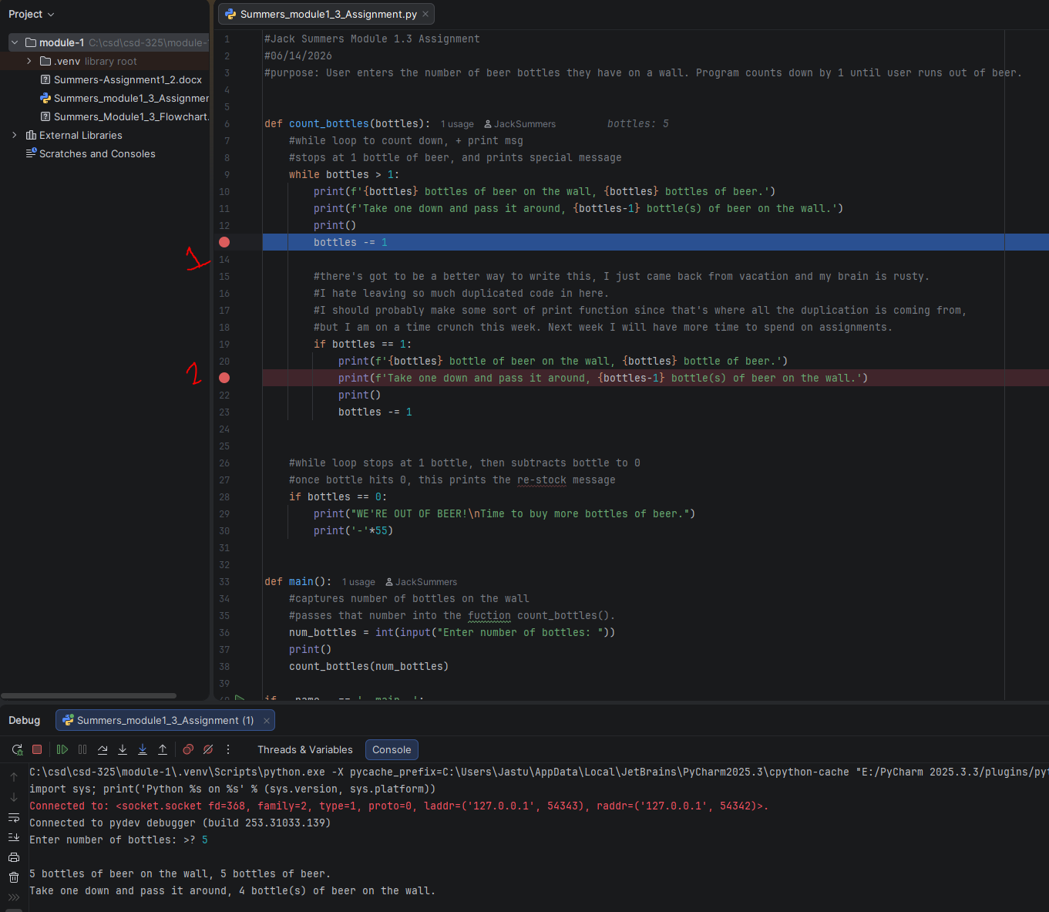

Instruction8: Step into function.
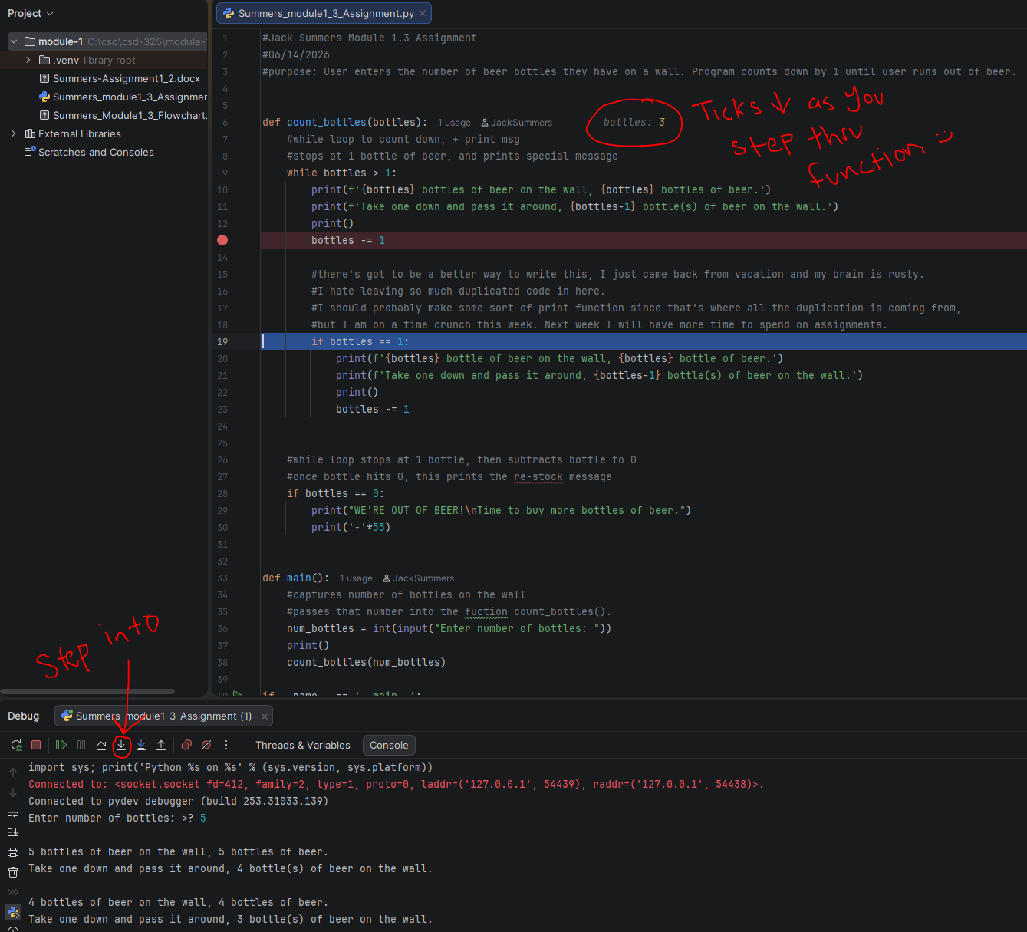

Instruction 9: Insert Error Into Code.
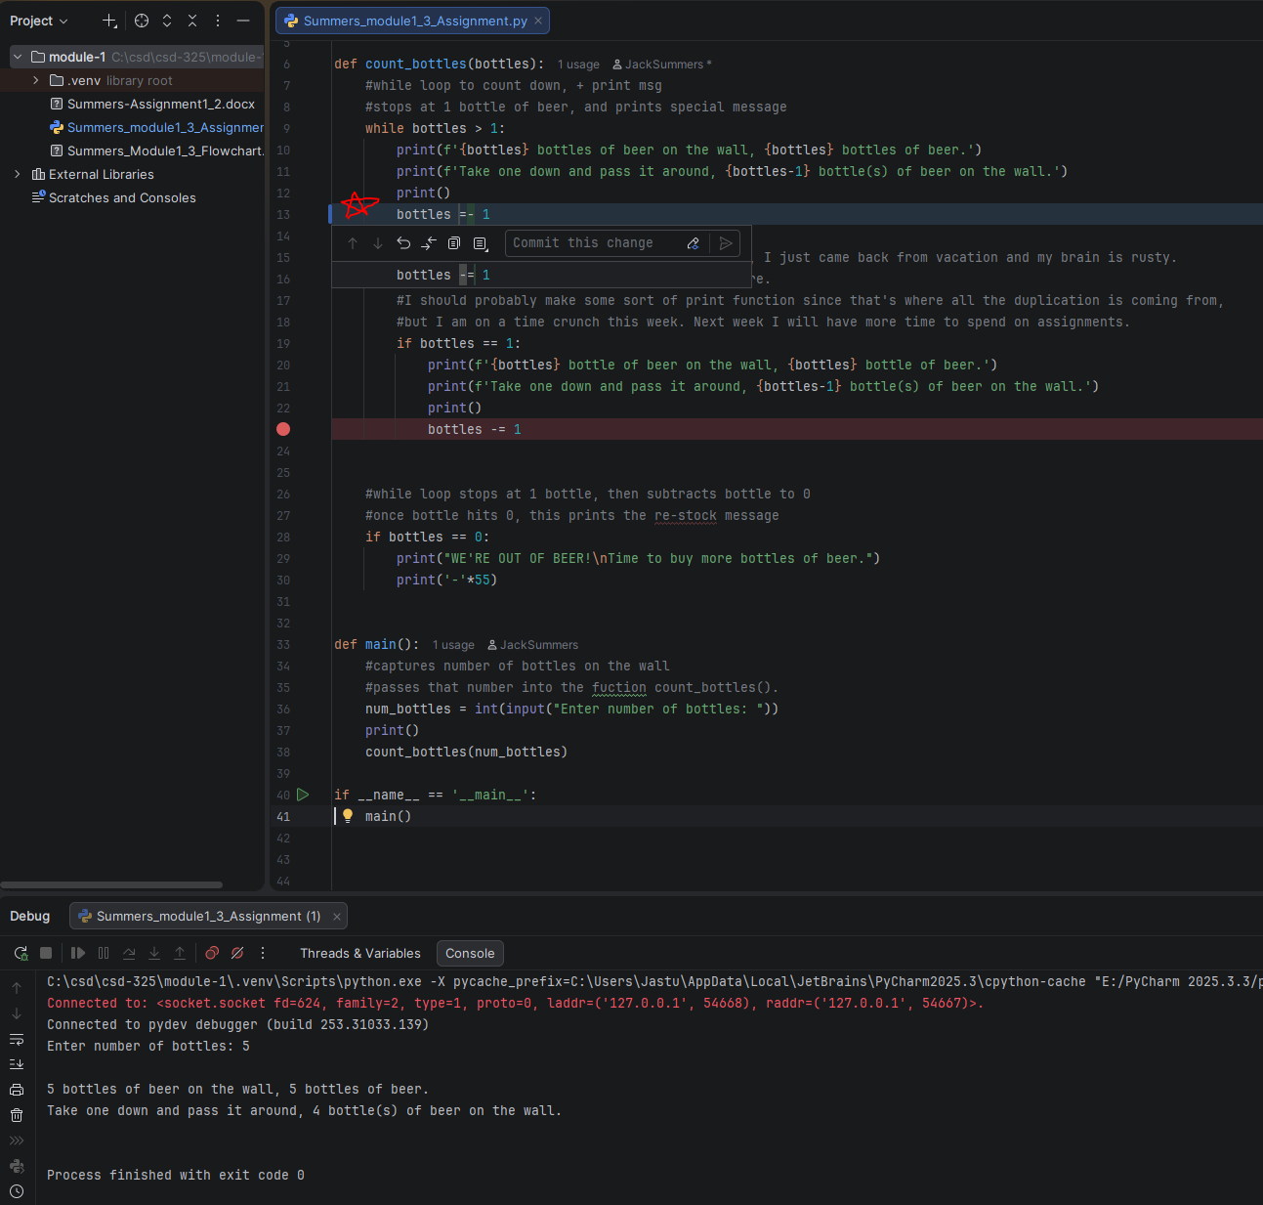
Debugger catches error.

